**User Manual for Indian Agro Services**

**Author: Tejesh Kumar Parangi**

**Table of contents:**

* 1. **Application Introduction**
  2. **Users of the application**
  3. **Needs of the user**
  4. **How my application fulfill the user needs**
  5. **How to use application (Logical explanation)**
  6. **Application Introduction**

“**Indian Agro Services**” is a collaborative platform for all the account holders (Farmers) to get use of many sessions hosted by other users on different farming techniques.

This application will allow farmers to select a connection (session hosted by a user) and can add it to his profile so that he can attend to the session to gain knowledge on that topic.

He can also add a new connection (host a new session on a farming topic) so that other users can add it to their profile to attend to.

* 1. **Users of the application**

As explained above, Farmers are my users.

This also can be classified into two types:

1. Free users (who doesn’t hve credentials to login)
2. Account Users (who can log into the application using their credentials )
   1. **Needs by the user**

Knowledge sharing is always beneficial to others who are in need of it. There are several instances in our country where Farmers are unaware of several farming techniques due to which they can’t adopt those techniques usefully, productively and profitably.

The user needs to gain the knowledge on the techniques-based on his needs.

* 1. **How my application fulfills the user needs**

My application “**Indian Agro Services**” will allow the farmers (of course if they have an account in my application) to check for the session that are being organized in different Farming techniques. They can add a session to their dashboard so they can attend it.

This will allow the farmers to gain the knowledge on the desired technique and can apply the gained knowledge in his own farmland.

* 1. **How to use application (Logical explanation)**

**Site map of my application:**

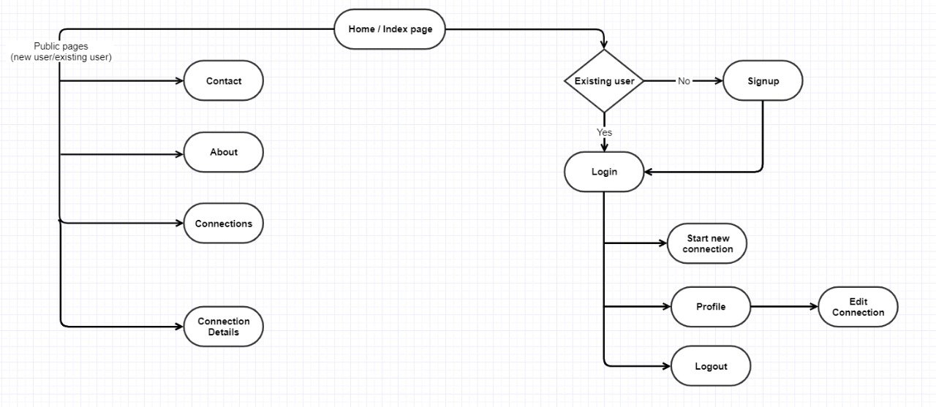

**All farmers (whether he has account in my application or not) can access Home page of the application through which all the users can access all the general site navigations like About, Contact, Connections and Connection Details. If the User does not have any account, he can Sign up and register for the application to use the services. Once the user signs up he can add the training sessions he wants to add. Also, the user can create the training that he wants to host. He can edit the connection that he has created.**